ORGANISATIONAL BEHAVIOUR

WEEK 2

SNEHA GUPTA

# DEFINING PERCEPTION

1. Process of giving meaning to a sensory stimulus through organizing and interpreting
2. Its how we see things
3. Subjective

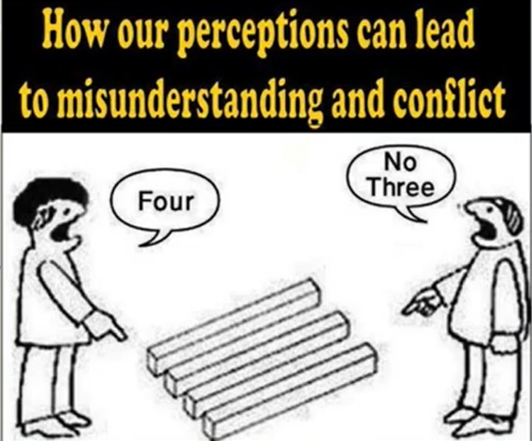

1. Misunderstanding or miscommunication can arise due to subjective perception.
2. Encourages diverse perspectives & creative ideas

# BASIC ELEMENTS OF PERCEPTION

1. Selection & screening of information
2. Organization of stimuli –
   1. organizing these stimuli based on our need and experience.
   2. We don’t give attention to all of our stimulus.
   3. We organize important stimulus acc to our priorities.
3. Sub processes of perception –
   1. Stimulus (plural of stimuli) – external factor that can be percieved
   2. Attention – focusing on specific stimuli that seem important
   3. Registration – noticing & acknowledging the stimulus
   4. Interpretation – making sense of stimulus based on context.
   5. Feedback – reacting or seeking clarification based on the interpretation.
   6. Consequence (the response) – the outcome of the perception process

# PRINCIPLES OF PERCEPTUAL SELECTION / HOW WE SELECT THE STIMULUS / FACTORS INFLUENCING PERCEPTION

1. Importance.
2. External & internal factors.
3. External factors: those external factors which grab our attention
   1. Intensity – stronger stimuli (eg: loud sounds, bright lights) capture attention
   2. Size – larger stimuli (eg big billboards)
   3. Contrast – (red on white bg)
   4. Repetition – repeated course of stimulus increases attention
   5. Motion – moving stimuli – most likely to be noticed
   6. Novelty & familiarity – new or well known stimuli can both attract attention
4. Internal factors: us. There is something within us which made us chose this stimulus.
   1. Habit – routine behaviours influence what stimuli we notice (eg. Cyclists noticing bicycles)
   2. Motivation & interest – needs / interests (eg. Thirst, hobbies)
   3. Learning – prev knowledge / beliefs (spiritual individuals noticing places of worship)
   4. job role & specialization – (hr manager focuses on people related data)

# PERCEPTUAL ORGANISATION / METHODS TO ORGANISE PERCEPTUAL STIMULI

1. grouping
   1. humans have a tendency to group certain stimuli together, to make sense out of it
   2. to group, we subconciuosly use some specific methods which are listed below.

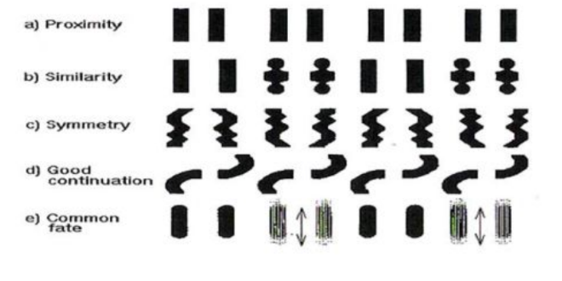

* 1. proximity – how close they are
  2. good continuation – perception of flow in the stimuli
  3. common fate – going in a same direction

1. closure

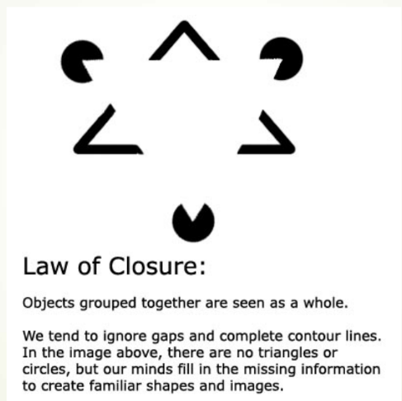

1. figure-ground
   1. depending on what we chose to see, the background things become blur.



* 1. this can lead to problems because,
  2. we consider something as important & all the other things become unimportant.
  3. But sometimes things we neglect, to see as background, can also be important.

1. perceptual constancy



1. optic illusions
   1. problem with perceptual principles is optical illusions.
   2. Perceptual organization can lead to illusions where stimuli are mis interpreted





# SOCIAL PERCEPTION

1. The process of combining, integrating & interpreting info about others to gain an accurate understanding of them.

# ATTRIBUTION THEORY

1. Understanding the causes of other’s behaviours (internal / external factors)
2. Ex: deciding if someone’s irritation is due to their nature or external circumstances

# SOCIAL IDENTITY

1. Personal identity – the chars that define a particular individual
2. Social identity – defining a person in the contect of their membership in various social groups
3. Social identity theory – we perceive ourselves & others based on both unique chars (personal identity) & our membership in various groups (social identity)

# PROBLEMS WITH SOCIAL IDENTITY

1. Stereotyping
   1. Generalizing qualities based on social group identity
   2. Assuming all Punjabi people are strong and hefty
2. In-group bias
   1. Favouring members of one’s own social group & interpreting their actions more positively
   2. Ex: justifying actions of someone from your own social group, while criticizing the same actions from someone outside the group.

# PERCEPTUAL BIASES IN SOCIAL PERCEPTION

1. Fundamental attribution error : Overemphasizing internal causes for others' behavior while downplaying external factors.
2. HALO EFFECT : Judging someone entirely based on a few positive traits, leading to biased evaluations.
3. Team halo effect : the tendency for people to credit teams for their success but not hold them accountable for their failures
4. Similar to me effect : perceiving people who are similar to us in positive light
5. Selective perception: the tendency to focus on some aspects of env while ignoring others.
6. First-impression error: making lasting judgements based on initial encounters

# IMPLICATION TO HRM

# ATTRIBUTION OF CAUSALITY

1. Kelly’s theory : involves 3 criteria to attribute behaviour to internal & external causes:
   1. Consensus : do others feel the same?
   2. Consistency: does this happen often?
   3. Distinctiveness: is this behaviour unique to certain situations?
2. Example: understanding wether a boss’s irritability is due to their personality or external factors.

|  |  |  |  |
| --- | --- | --- | --- |
| Attribution -> | personal | stimulus | Circumstance |
| consensus | Low  *Very few people feel that the boss is irritable* | High  *Very high people feel that the boss is irritable* | High  *Very high people feel that the boss is irritable* |
| distinctiveness | Low  *You feel many people in your office are irritable* | High  *You feel only this person is irritable* | Low  *You feel many people in your office are irritable* |
| consistency | High  *You feel this many times* | High  *You feel this many times* | Low  *Sometimes you feel they are irritating, sometimes you feel they are good* |

# POWER OF PERCEPTION

1. Self-fulfilling prophecy – when we start perceiving about some person in a certain way, there are more chances that it will become true.

When you percieve someone as “good” or “bad”, overtime you’ll see they will fulfil your expectations. How does it happen? Let me give an example

Theres a teacher, and she percieves backbenchers as notorious students & front benchers as disciplined students. Now, there can be number of reasons why that student might be sitting in the back. It can be as if hes tall, and thats why hes sent to the back, but being tall dosent mean they have to be notorious. But, in most cases, back benchers come out to be notorious.

* 1. Pygmalion effect – expectations influence others to behave in such a way that confirms those expectations
  2. Golem effect – setting low expectations can lead individuals to meet only those low standards

# JOB STEREOTYPES

1. Generalising qualities to all members of a social group or a job role.
2. Ex: scientists male, middle-aged, lab coats & doctors (gender-based stereotypes)

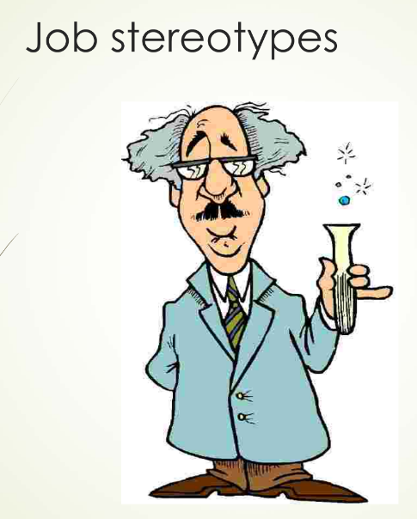

# STEREOTYPING

1. A belief that all members of specefic grps share similar traits & are prone to behave the same way.
2. Negative impact:
   1. Selective pereption
   2. Bias & prejudice
      1. Bias : inclining towards or against certain individuals based on stereotypes.
      2. Prejudice: prejudging individuals based on stereotypes before gathering sufficient info.
3. Glass ceiling effect: invisible barriers prevent women and minorities from advancing to top positions.
4. Impression management: candidates may use stereotypes to their advantage during interviews.

l